Ans No 1

ANS NO 1a

Create 10 X 1 matrix

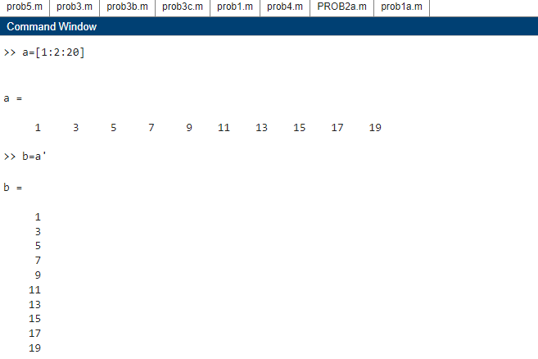

Sum:

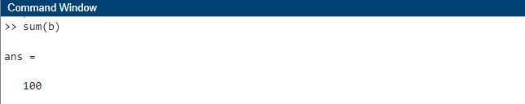

Ans No. 1b

Create 10X1 matrix:



Create a matrix D:

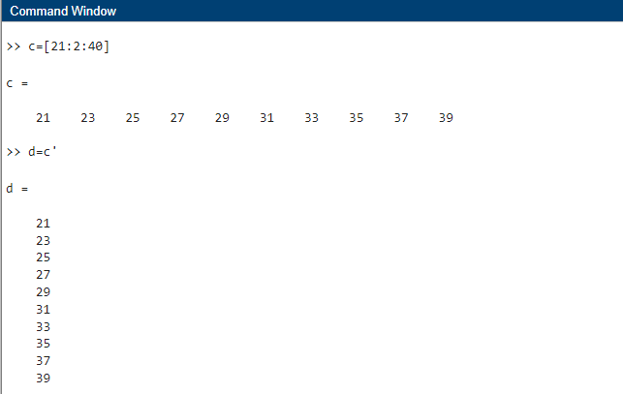

Decending order vectors

D(1)=b(10)

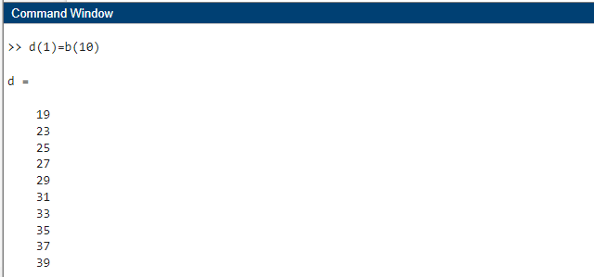

D(2)=b(9)

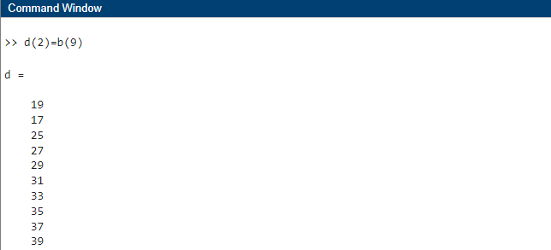

D(3)=b(8)

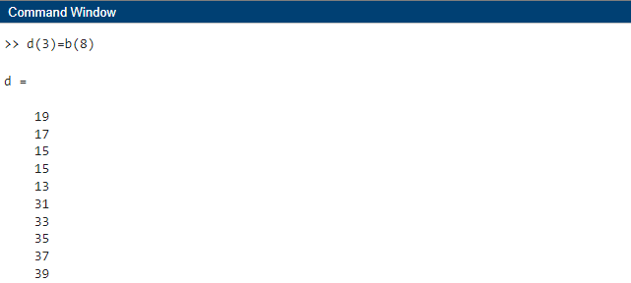

D(4)=b(7)

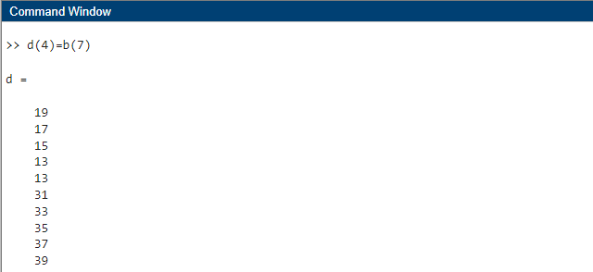

D(5)=b(6)

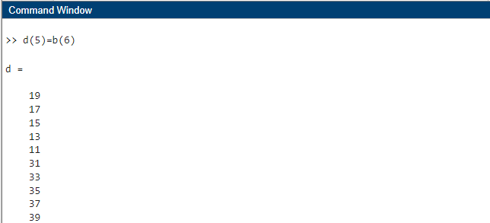

D(6)=b(5)

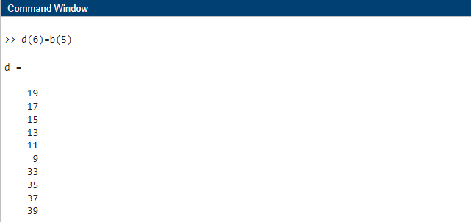

D(7)=b(4)

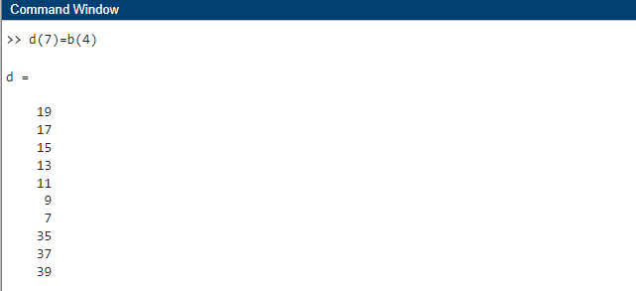

D(8)=b(3)

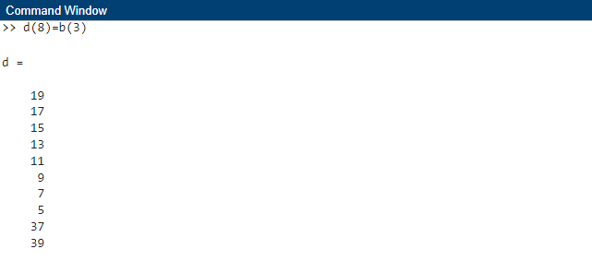

D(9)=b(2)

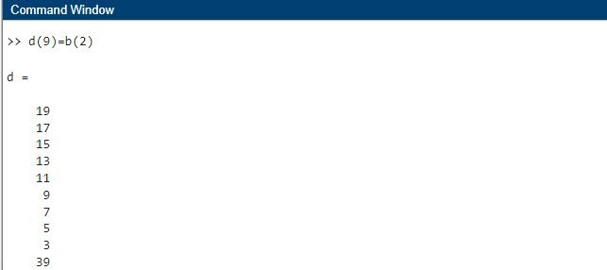

D(10)=b(1)

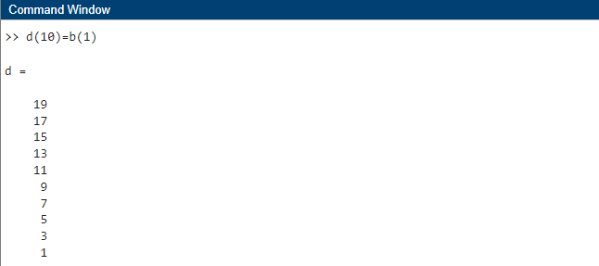

Ans no 2

Ans no 2a

Matrix of 5X5

A=[1 5 7 3 4; 10 6 8 9 2; 11 13 15 17 19; 12 14 16 18 20; 22 23 25 27 29]

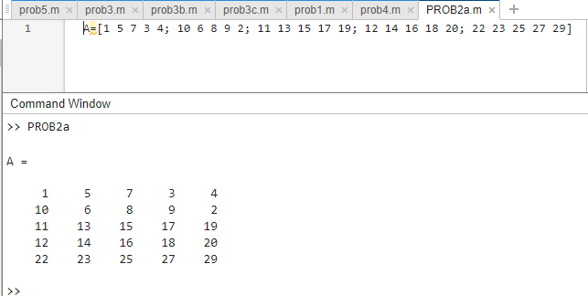

Extract b:

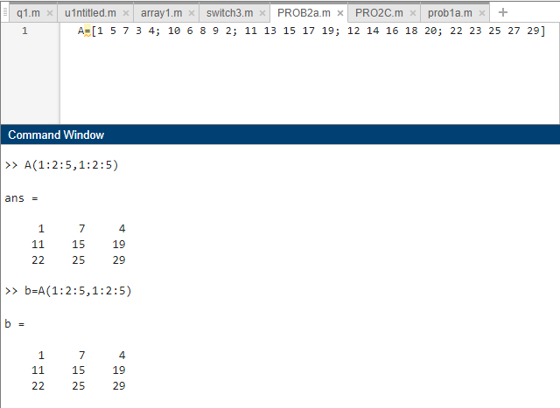

Ans No. 2b

Extract diagonal and determinant :

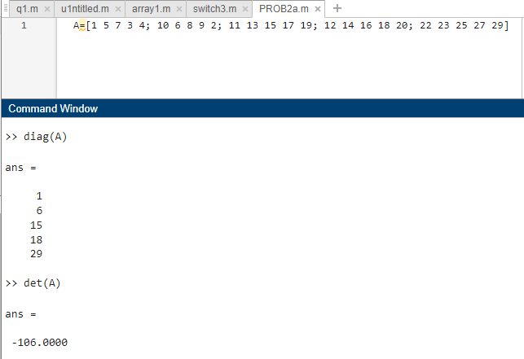

Ans No. 2c

Create a matrix c:

A=[1 5 7 3 4; 10 6 8 9 2; 11 13 15 17 19; 12 14 16 18 20; 22 23 25 27 29]

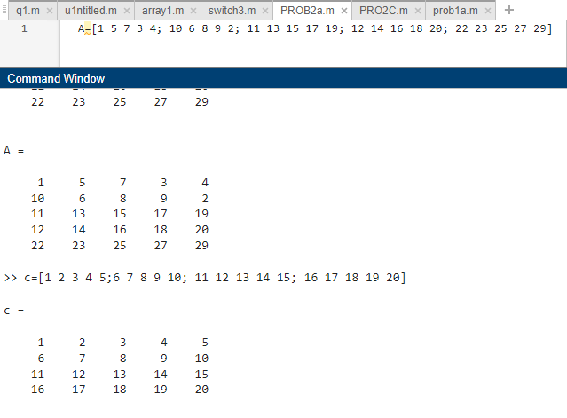

A Multiplication with C:

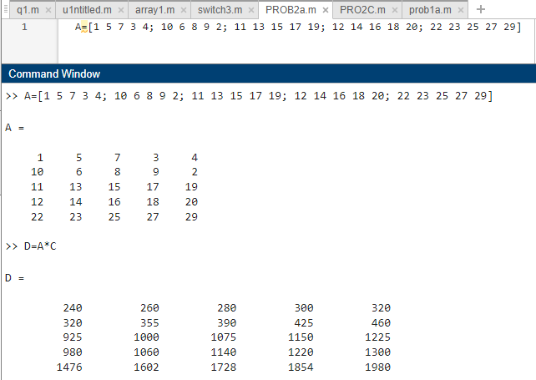

Element wise multiplication of A with B :

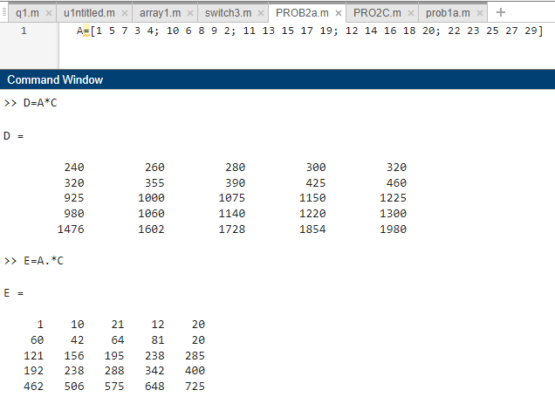

Both the results are not same as shown above.

Ans No. 3

Code using if-elseif statements:

x=input('enter the input value x:');

%using if-elseif statement

if(x>pi/2)

disp('y=1');

elseif(x>=0 & x<pi/2)

disp('y=sin(x)');

else

disp('y=0');

end

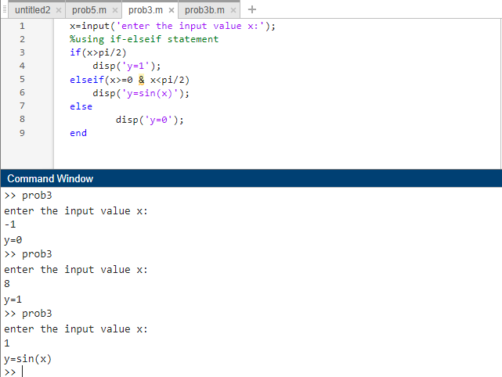

Code using switch case statement:

x=input('enter the input value x:');

%using switch statement

switch (x)

case x*(x>pi/2)

disp('y=1');

case x*(x>=0 & x<pi/2)

disp('y=sin(x)');

otherwise

disp('y=0');

end

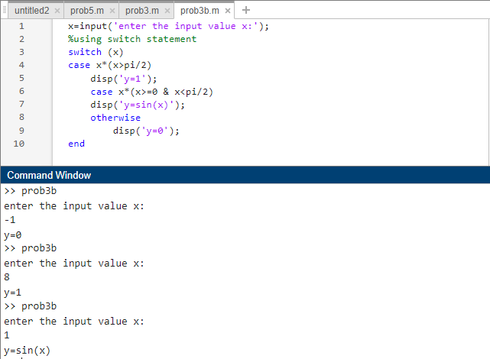

Plot function of Yand X:

fplot(@(x)1,[pi/2 5],'b')

hold on

fplot(@(x)sin(x),[0 pi/2],'r')

hold on

fplot(@(x)0,[-5 0],'g')

hold off

grid on

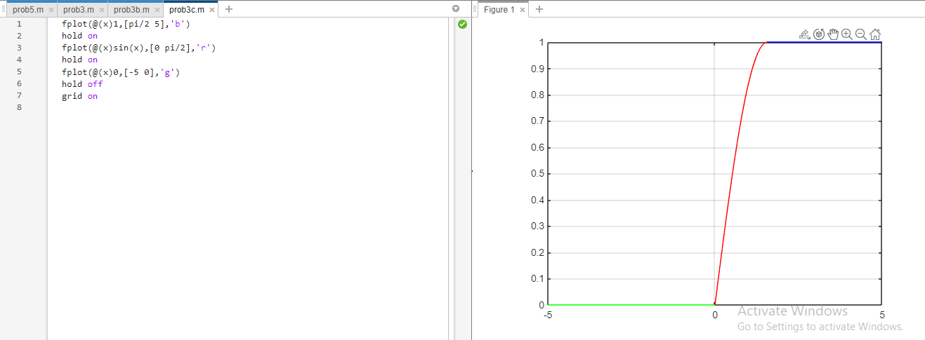

Extract the function between –pi/4 to pi/4:

fplot(@(x)sin(x),[0 pi/4],'r')

hold on

fplot(@(x)0,[-pi/4 0],'g')

hold off

grid on

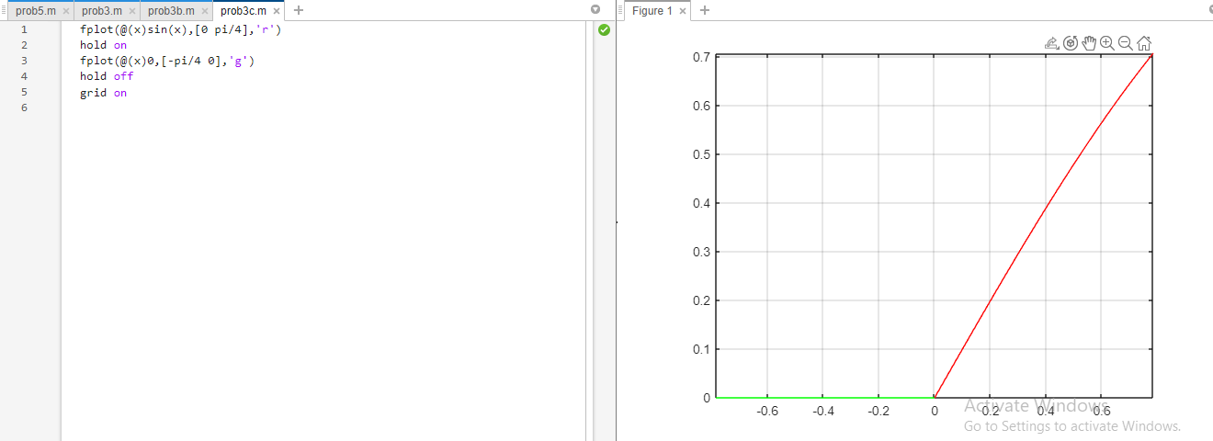

**Ans No. 4**

n=input('inter the value of n');

k=[];

for i=1:n

for j=1:i

k=[k,i];

end

end

disp(k)

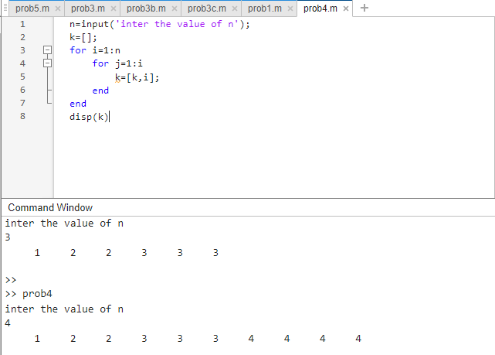

**Ans no 5**

**Ans no 5a**

a=0.5;b=1;

t=0:1:10;

x=(exp(t.^a)).*log(b.*t);

y=t;

plot(t,x,t,y);

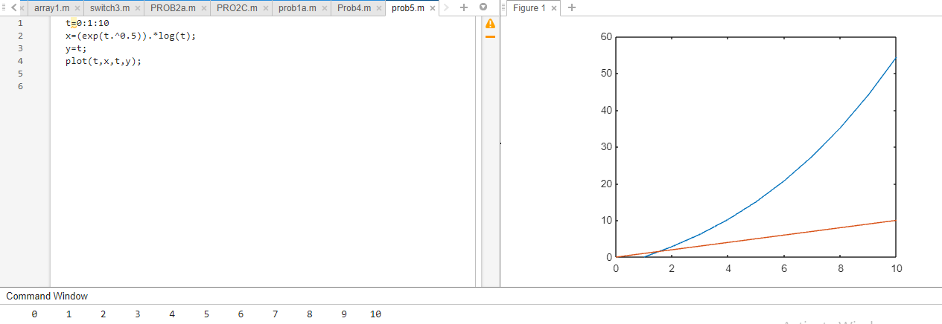

**Ans no 5b**

a=0.5;b=1;

t=0:1:10;

x=(exp(t.^a)).*log(b.*t);

y=t;

plot(t,x,t,y)

axis([0 5 -50 50])

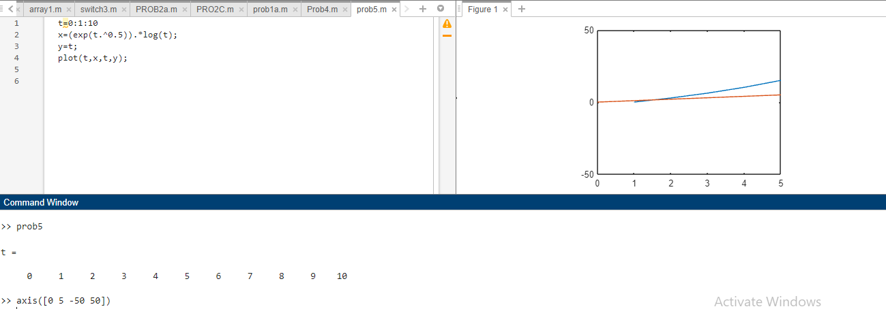

**Ans no 5c**

a=0.5;b=1;

t=0:1:10;

x=(exp(t.^a)).*log(b.*t);

y=t;

plot(t,x,t,y,'-o','Markerindices',1:2:length(x),'Linewidth',5, ...

'MarkerSize',5,'MarkerEdgeColor','r','MarkerFaceColor',[1,0.5,0.5]);

axis([0 5 -50 50])

grid on

xlabel('time in sec');

ylabel('Response in cm');

title('functions x and y');

legend('a=0.5,b=1');

